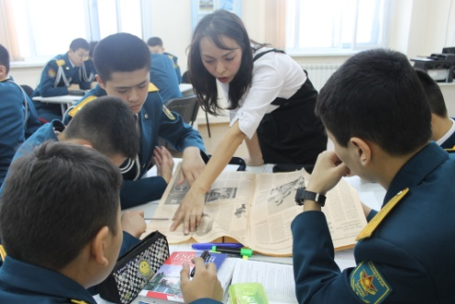 |  | Ф.И.О. Сапарходжаева Айгуль Пазилбековна,  РШ «Жас ұлан» им. С.Нұрмағамбетова,  г. Астана
The theme of the lesson: Mass media |  | Teacher name: Saparkhojaeva A.P.
Date : 18.04.2017 |  | Number present:
Grade: 9 “A” |  | Absent:
Learning objectives that this lesson is contributing to |  | - Use imagination to express thoughts, ideas and feelings  - Revise new vocabulary from the previous lesson  - Explain and justify their own point of view on a range of general and curricular topics  - Revise grammar material (passive voice: present, past, future)  - Enlarge ulans’ vocabulary
Lesson objectives |  | All learners will be able to:
- Know the information about the mass media
- Make a presentation on each task
 |  | Most learners will be able to:
- Make up sentences using grammar
- Create and ask questions
- Do grammar exercises
Some learners will be able to :
- Write a summary about the mass media
Language objective |  | - Express their opinions about the achievements in mass media  - Develop ulans’ oral speech
Previous learning |  | Newspaper
Use of ICT |  | - Active board
The course of the lesson
Planned timings | Planned activities |  | Resources
Start  2 min  10 min  15 min  10 min | - Org. moment  Now ulans let’s make a circle and answer my question:  What can you imagine with the word “Mass media”?  In this way you must divide into 3 groups, they are: ….  - Phonetic drills  Ulans before beginning our lesson please answer my questions:  - Do you read the newspapers or magazines?  - What kind of newspapers do you like to read?  - What are your favorite TV programmers?  - How many hours a day can you watch TV?  - Why do you use the Internet?  - Do you listen to the radio? What radio FM can you listen to?  - Can you live without Internet, TV or radio? Why?  Now ulans let’s revise our new words which you had taken at the previous lesson, repeat after me:  Scan, section, cartoon, headlines, forecast, editorial, opinion, sensational, gossip columns, classified section, want ads, reporters, advertising.  Now give me the translations of these words. Well done. Ulans I give you out the newspapers of Britain, you must find your new words from these newspapers and circle them where they are showed.  Can you tell me the differences between our local newspaper and British newspaper?  Very nice  - Guessing the theme of the lesson and make a presentation  Now ulans I think you understand the theme of our lesson today, who tells me what is the theme of our lesson ? Mass media.  The next task for every group is to make a presentation of the achievements in radio, television and internet. You’ve got only 5 minutes.  Ok, the time is up. Please show your presentation for us. Each group give your opinions with the strategy “Two stars and one wish”  Good for you, thanks a lot.  - Doing grammar exercises using the strategy “Envelope” Now ulans the next task is you should open the envelope and take the tasks for all the members of the group, there are two questions:  - Give the rule of the passive voice ( Present, Past, Future)  - Do grammar exercises using passive voice(there are 5 exercises)  After doing exercises, ulans will change the papers and begin to check his partner. Give him his own mark.  - Giving homework and marks.  Now ulans write down your hometask. Your homework will be : ex 1 p 163, ex 4 p 164  And I’ll give you marks after checking up your sheets of paper in doing grammar exercises.  - Reflection  - What question do you have for the teacher?  - What was very interesting in our lesson today?  - Do you like to work in groups?  Please can you stick your stickers on the board :  - I knew it (red)  - I understood it (green)  - I want to know for the next lesson (yellow)  - The end of the lesson  The lesson is over!  Goodbye, ulans!  Goodbye, teacher!  You are free |  | active board  newspapers  Posters and stickers  Envelope and  Sheets of paper  stickers

