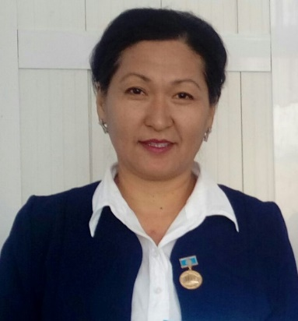
Askar Kuralay,
South Kazakhstan oblast
Otyrar region
Secondary school named after M.Shakhanov

There is not much fresh air

The Plan of the Lesson
Motive
- Organization moment
- Phonetic drill
- Checking up the home task
- Brainstorming-Proverbs
Basic part
- Presentation the new material
a) Vocabulary
b) Reading activities
c)Matching activities
d)Grammar rule
e) Relaxing
VI. Conclusion part
a) Speaking activities.

VII. Reflection
VIII. Assessment
a) Giving home task.
b) Marking.
c)The ending of the lesson.
- Grade: 6 “A”
- The theme of the lesson: Step 3. “ There is not much fresh air”
- The aims of the lesson:
- To develop students’ writing, reading skills, oral speech and ability to understand the texts about healthy lifestyle;
- To develop creativity doing grammar exercises;
- To talk about different lifestyles;
- The type: Consolidation lesson
- The methods: question-answer, work with pictures, doing grammar exercises, reading and speaking, group work and pair work.
- Inter subject connection: Kazakh, Russian, Biology.
- The aids: pictures, proverbs, diagrams, rules,cards.

The Procedure of the lesson

The stages of the lesson | Teacher | Students | Time
I. Organizational moment:  a) Greeting:  b) Talking with duties: | -Good afternoon, dear pupils!  -How are you today?  -I’m fine, thanks! I’m very glad to see you.  -What season is it now?  -Who is on duty today?  - Is anybody absent today? | - Good afternoon, dear teachers!  -We are OK, thank you!  -And you?  -We are too!  It’s spring.  -I’m on duty today.  -All are present.
II. Phonetic drill  - a) Psychological training: | Look at the board. You see different figures. Choose the figure you like. | -I promise
- Warm-up: | People can’t live without food. It’s very important for us.  -What you eat to stay healthy?  -Can you say any proverbs about food and drinks and health?  -Yes, you are all right. When you use healthy food, you will have healthy lifestyle.  And today we will speak about different lifestyles. | -We eat healthy food  1.Health is above wealth  2.Appetite comes with eating  3.Food is source of power
III. Presentation  a)Vocabulary.  b)Reading activity  с)Matching activity  d)Grammar rule  IV.Relaxing.  V.Practice in writing. | The Theme of the lesson is “There isn’t much fresh air”  The motto of the lesson:”Food is source of power” « Ас-адамның арқауы» .  Lifestyle  Much/ many  A lot of  Healthy/unhealthy  Ex: 1a”Have you got a healthy lifestyle?”  Ex:1 b). Match the words in A with  In B, then ask and answer the questions.  1-c 5-b  2-g 6-d  3-a 7-e  4-f  Pronouns:a lot of,much and many.  We use a lot of or lots of with countable and uncountable nouns to describe a large number or quantity. We normally use them in affirmative sentences.  We use much with uncountable nouns to describe a quantity of something.We normally use it in questions and negative sentences.  We use many with plural nouns to describe a number of people or things.We normally use it in questions and negative sentences.  There are many apples on the tree  There are many cars in the street  There isnt much water in the bottle  There is not much coffee in the cup  Ex.3Complete the sentences with much or many.  1-much 5-many  2-many 6-many  3-much 7-much  4-much 8-many | Students will read the texts and match the texts with the photos.  Students will do ex.  Students listen to teacher.  In chour.  Students will write the ex.down in your notebook.
VI.Conclusion part.  a).Speaking activities.  b)Completing the diagram.  c)Remember the rules.  VII.Reflection.  VIII.Assessment. | Answer the questions.  Work with cards.  “Modern lifestyle “  People need to be active to be healthy.Our modern lifestyle and all the conveniences have made us sedentary.And that is dangerous for our health.In order to be healthy we must eat healthy food regularly.  1.Get up early and go to bed early.  2.Take regular exercises.  3.Eat healthy food.  4.Wash your hands before you eat.  5.Go in for sports.  6.Get fresh air.  7.Keep to a diet.  8.Never smoke.  9.Dont drink alcohol.  10.Be physical active. | Students will answer the questions.  Students will fill the diagram.  Students will read and remember.  Saying good-bye.

