Alzhanova Palmira Dihanbaevna,

School: 102

Sport. Sport in my life

Adjectives: personality

Term 2
"Sport, health and exercise"
Date: 16.11.2018
Grade 8Б. |  |  | Number present:12 |  | Number absent:
Learning objectives(s) that this lesson is contributing to |  | 8.2.5.1 recognise the opinion of the speaker(s) with little or no support in extended talk on a wide range of general and curricular topics  8.5.5.1 develop with support coherent arguments supported when necessary by examples and reasons for a growing range of written genres in familiar general and curricular topics  8.C2 use speaking and listening skills to provide sensitive feedback to peers  8.S7 use appropriate subject-specific vocabulary and syntax to talk about a range of general topics, and some curricular topics  8.UE12 use comparative degree adverb structures not as quickly as / far less quickly with regular and irregular adverbs.  Use an increased variety of pre-verbal, post-verbal and end-position adverbs on a range of familiar general and curricular topics
Lesson objectives |  | All learners will be able to:
- Apply vocabulary to describing personalities.
- identify the meaning of the text about a famous Kazakh sport.
- The values ​​of the sport "Quidditch" are revealed to compare the real game with the game from the Harry Potter movie
- Use adverbs of degree.
 |  | Most learners will be able to:
 |  | - Describe people's personalities using some support.
 |  | Some learners will be able to:
 |  | - Describe people's personalities building extended sentences.
Value links |  | Slides made by the children themselves what kind of sport they attend. Protection of work. Taking care of your body and health.
Cross curricular links |  | Physical education.
Previous learning |  | Project: A TV programme
Use of ICT |  | Smart board for showing a presentation, getting additional information, playing the audio files.
Intercultural awareness |  | Students will be aware of the significance of healthy lifestyle in the Kazakhstani culture and the global world.
Health and Safety |  | Breaks and physical activities used.
Plan
Planned timings | Planned activities |  |  | Resources
Beginning the lesson | The lesson is begun with girls who carry out the song.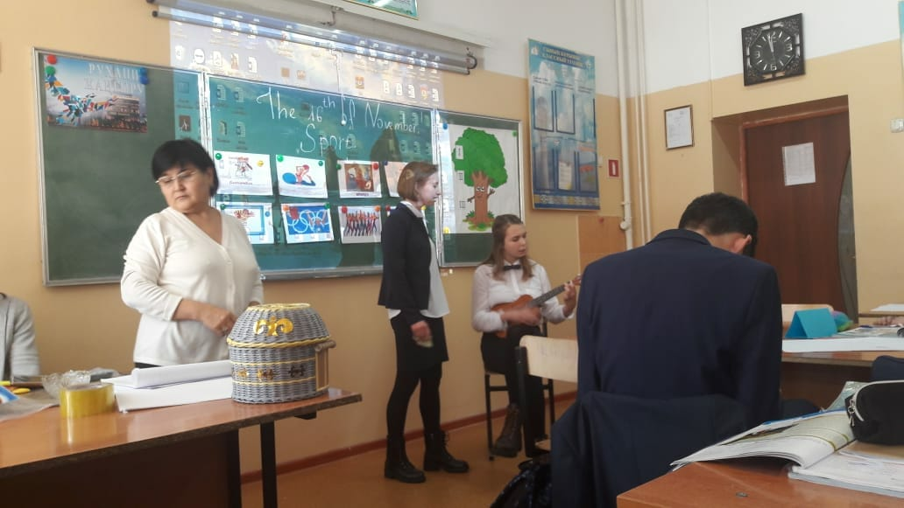  The teacher sets the lesson objectives, letting students know what to anticipate from the lesson.  Warm up.  Start thinking p.44. Answering questions.  1. Who are the most famous sportspeople in Kazakhstan? (2Ilia Ilyin, Gennady Golovkin, Alexander Balandin, Michael Jordan, hockey team- Bars, Biathlon, figure skating)  2.What is your favourite sport?  3. What personal qualities do you need to become a successful sportsperson? (determination, talent, dedication, confidence).  •Think of as many Kazakh sports people as you can.  •What are the positive side and the challenges of the life for sports people?  Cluster "Personality adjectives".
Main Activities | 4. Work with vocabulary. Aikido, aerial,yoga, rugby, boxing, swimming, weightlifting, pilates, zumba.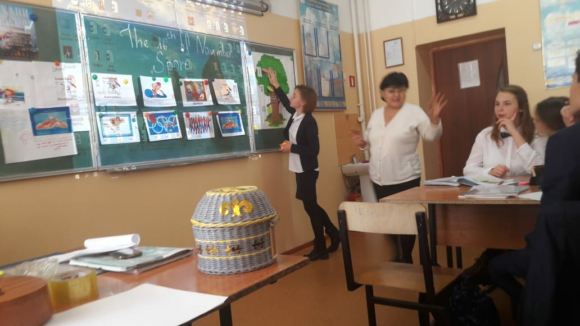  5. Devision into groups.Children from the table take pieces of paper. Gather the puzzle. Their assignments will prepare a group work. The protection of the sport they pulled out. The names of groups are: Boxers, Basketballers, Swimmers.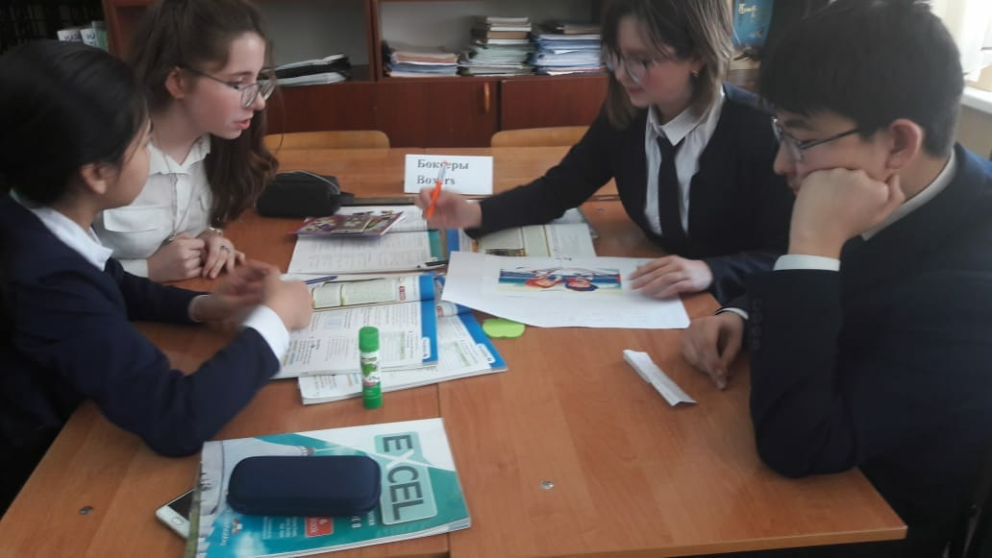  6. Wortk with the text from the students book.  1Reading of the text yourselves for 2 times. Work with the new words from the text. Giving synonyms and antonyms of these words.Students ask questions on the text. By answering to them we understood how they understand the text.  2. Students compare the play “Quiddish” from the film Harry Potter with the real play how people play it now in GBin real life.  3.Work with the slide. Children must find who is in the slide. Speak about them,Using the words: who, where, when, what sport hem goes in.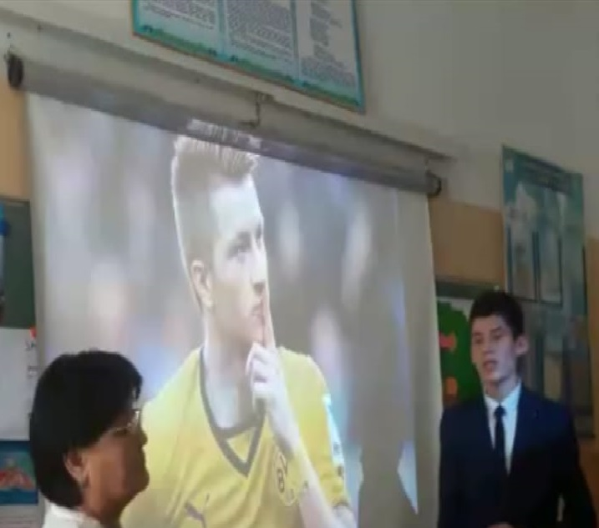  4. The slides that the children themselves made what sport they do, is there any benefit from this? You must tell how they lead the healthy lifestyle.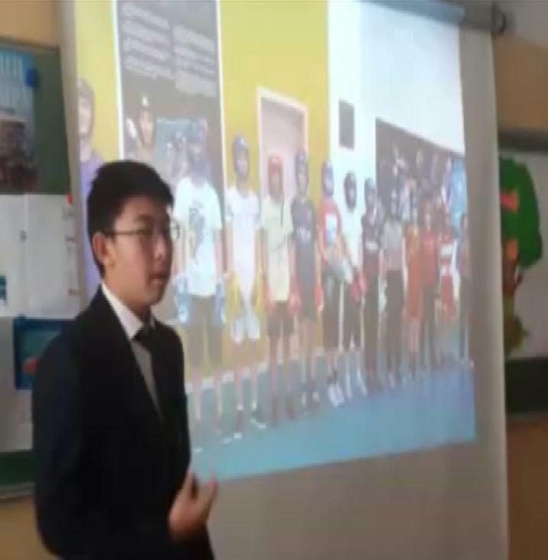  5. Give the English equivalents for the following. Make up sentences. Зимние виды сорта, хоккей, фигурное катание, легкая атлетика, художественная гимнастика, шахматы, тяжелая атлетика, гимнастика, плавание.  6.Writing time. Now we will do exercise from WB.Ex.3p.29.Cheching the exercise by reading.  Ex.4 p.30 Odd one out.  Ex.7 p.45. Guessing game.  Extra task. Writing practice.
Ending the lesson | 6.Answer to the questions from the characters of the tale, please.  1. Grandfathers question: Are people all over the world fond of sport and games?  2. Grandmothers question: What are the most popular winter sports do you know?  3. What other games are very npopular?  4. What ndo young girls and women go in for?. 5.What indoor games are the most popular?  6.What is the biggest stadiums in Almaty do you know?  7.Does sport help people to become stronger and healthier?  8. Giving the hometask WB p.32ex 8-9. Prepare control reading of the text, translate the text, learn new words.  9.Watching the tale” Repka”  Each point was marked by the students.
End  1min | Feedback: Teacher asks students what task was difficult to them and which pair worked well.
Additional information
Differentiation –  how do you plan to give more support? How do you plan to challenge the more able learners? |  |  | Assessment –  how are you planning to check learners’ learning? |  | Critical thinking
Differentiation can be achieved through the selection of activities, identification of learning outcomes for a certain student, provision of individual support to learners, selection of learning materials and resources based on the individual abilities of learners. |  |  | Assessment criteria:  - Give feedback to others orally.  - Apply topic related vocabulary in speech appropriately arranging words and phrases into well-formed sentences.  - Apply regular and irregular adverbs and comparative degree structures accurately.  Descriptor:  A learner:  - evaluates the peers’ answers.  - uses appropriate subject-specific vocabulary while speaking.  - applies the rule for comparative degree adverbs and their usage.  - Observation  - Feedback on the work  - Self-assessment |  | Students think critically, exploring, developing, evaluating and making choices about their own and others’ ideas

