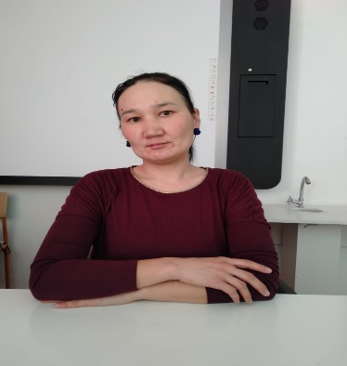
Батырбекова Асел Колганатовна,
Қостанай облысы, Арқалық қаласы, Ашутасты ауылы
А.С.Макаренко орта мектебінің
ағылшын тілі мұғалімі

Writing an article for a school magazine or school e-zine about festivals or unusual and interesting journeys

CLASS: 7 | Number present: | absent:
Learning objectives(s) that this lesson is contributing to (link to the Subject programme) | 7.C4 evaluate and respond constructively to feedback from others and dialoge of studing  7.S7 use appropriate subject-specific vocabulary and syntax to talk about a range of general topics, and some curricular topics7.W3 write with moderate grammatical accuracy on a limited range of familiar general and curricular topics
Lesson objectives | All learners will be able to: useappropriate subject-specific vocabulary and syntax  Most learners will be able to: use moderate grammatical accuracy in doing tasks  Some learners will be able to:discuss about festivals and unusual interesting journeys in a group
Assessment criteria | Apply topic related vocabulary in speech appropriately arranging words and phrases into well-formed sentences  Demonstrate the ability to write grammatically correct sentences on familiar topics.
Level of thinking skills | Application  Higher order thinking skills
Values links | 2) National unity, peace and harmony in our society
Cross-curricular links | Geography, Computer study
Previous learning | Making a brochure/leaflet
Plan
Planned timings | Planned activities (replace the notes below with your planned activities) |  | Resources
Start  10min | Org. moment:  Greeting the leaners. I’ll greet leaners and introduce with the learning objectives.  Psychological training.Play game:  Балалар бір- біріне жаксы тілектер айту аркылы жаксы көңіл куй сыйлайды.  You are kind, You are great, You are talented, You are clever,  You are nice, You are happy. which you wish. Then divide into three groups.  So pupils let’s begin our lesson, first of all choose “Travelling”, “Country”, “Sports”  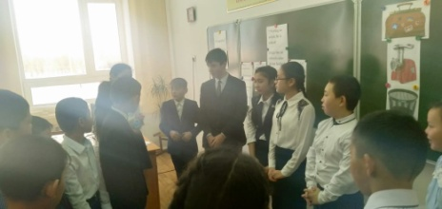 |  | htt://eslgames.com/  present  +perfect+game/  Express publishing  “Excel”  Express publishing “Excel”  Express publishing “Excel”  Express publishing “Excel”
Middle  5 min.  Group work  4 min  4min.  4 min.  Writing 5min.  3min. | I’ll say,to leaners “Now dear boys girls let’s exchange your exercise books and check your home task. There are keys on interactive board.”  Task 1. Pre-teaching: Activating current knowledje – what do you know about…(pooling) Watching a video  What do you know about festivals, unusual and interesting journeys?  Have you travelled abroad? How do you think, can you tell of the most memorable travel experence in your interesting journeys? I’ll say, So, our today’s new theme: “ Writing an article for a school magazine or school e-zine about festivals or unusual and interesting journeys”  New words  Mausoleum [mosәliәm]  Locate [lokeit]  reserve [rizәv]  museum[mju:ziәm]  Valley[vali]  Task 2. Vocabulary activity “Discussion”  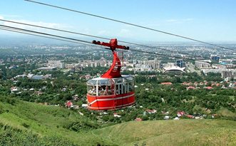  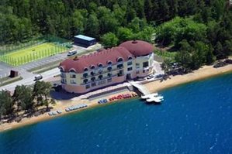  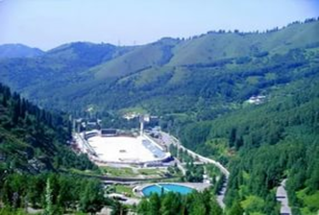  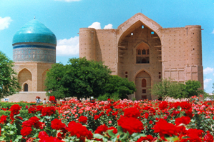  I’ll give flashcards to leaners with pictures. Look at the pictures. Discuss, as in the example and work in pair, then in a group. Share your ideas what do you see in this picture.  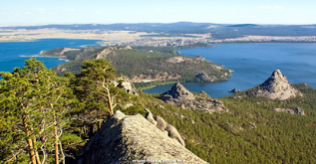  Descriptor A leaner  Names and describes the pictures;  Tells his partner about his travel experience;  Task 3. “Work with poster”  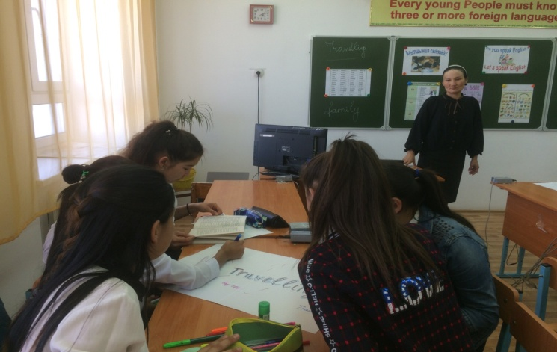  What do you know about festivals, unusual and interesting journeys?  Have you travelled abroad? How do you think, can you tell of the most memorable travel experence in your interesting journeys?  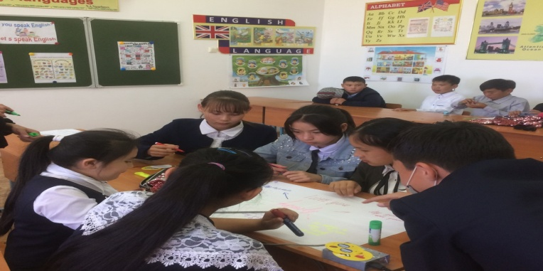  Descriptor A leaner  Makes sentences using words from teacher’s task  Uses present perfect to answers;  Task 4 “Who is the quickest?”  Write about your festivals or unusual and interesting journeys.  1 Where have you gone?  2 What have you done there?  3 What the weather has been like in that place?  4 How have you felt coming home?  5 What you will always remember about that place?  Descriptor A learner  Writes with grammar accuracy;  Makes up a story connecting sentences into paragraphs;  Task5  “Writing an informal e-mail giving news.”  You are spending a week somewhere in Kazakhstan. Write an email to your English pen-friend. (50-70words). Follow the plan: write: Para 1: Where you are, who you are with, what you think of the place (Greetings) from …I’m … . I’ve never… . Para 2: What you have done/seen so far – haven’t done/seen yet (I have been here for…I’ve …but I haven’t …yet.) Para 3: when you are coming back; closing remarks I’m coming back in … .  Descriptor A learner  Writes an email following the plan about a range of general topics
End Feedback  3 min. | During a lesson I have: learnt about…  remembered  known that  Now I know: speak about  write  Now I can: speak about….  write… |  | Magazine:  «Ағылшын тілін  оқыту әдістемелігі»
Assessment 2min. | During the lesson I’ll assess leaners with oral assessment and count “Well done”, “Good”, “Try again”, cards. |  | Magazine:  «Ағылшын тілін  оқыту әдістемелігі»

