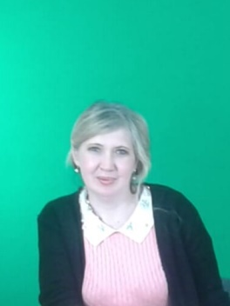
Кривенко Юлия Юрьевна,
учитель английского языка,
общеобразовательная школа № 4 п. Вольный
Абайского района Карагандинской области

Having fun

Short - term plan Unit 8 Having fun. | School Secondary school 4
Date: 14.05.2019 | Teacher name: Krivenko Y.Y.
CLASS: 3 | Number present: | absent:
Theme of the lesson: | Fun places.
Learning objectives(s) that this lesson is contributing to | 3.3.5.1- understand the main points of short simple texts on a limited range of familiar general and some curricular topics by using contextual clues;  3.2.4.1- respond to the questions on a limited range of general and some curricular topics.
Lesson objectives | All learners able to:  - Identify the main points of short supported talk when listening with some supports  - Recognize the main points of short simple texts about volcanoes with some errors  Most learners will be able to:  - Identify the main points of short supported talk without any support  - Recognize and point out the main points of short simple texts when reading about volcanoes without errors  Some learners will be able to:  - Identify and Explain the main points of short supported talk independently  - Conclude the main points of short supported talk without any errors  - Identify the main points of short supported talk when listening with some supports  - Recognize the main points of short simple texts about volcanoes with some errors  Most learners will be able to:  - Identify the main points of short supported talk without any support  - Recognize and point out the main points of short simple texts when reading about volcanoes without errors  Some learners will be able to:  - Identify and Explain the main points of short supported talk independently  - Conclude the main points of short supported talk without any errors
-identify the main points of short simple texts when reading with 75 % accuracy.
- give simple answers to the questions on fun places with considerable support

Most learners will be able to:
- identify the most points of short simple texts when reading with 85 % accuracy.
-give full answer the questions on fun places with limited support.

Some learners will be able to:
- analyze the main points of short simple text when reading with 95 % accuracy.
- answer the questions making a short story in 3-4 sentences without any support.
Assessment criteria | -identify the main points of the simple texts about fun places appropriately  -answer the questions on fun places with some support
Level of thinking | Application.
Value links | Tolerance. Mutual respect.
Cross curricular links | Art, English.
ICT skills | Computer, active board, flashcards, poster.
Previous learning | Water everywhere.

Lesson plan

Time | Planed activity. |  | Resources
Beginning  5 min | Greeting the students. Hello everybody! I am glad to see you!  Warm-up activity. Strategy “Word map” learners complete the map guessing the theme of lesson. They give their association  Group division “Mosaic” Pupils form 3 groups according to the pictures they have chosen. |  | Active board
Middle  30 min | 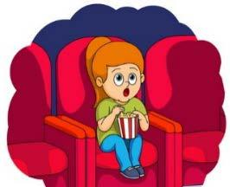  Activity 1. Pre-reading activity. Match the pictures with the words. Active method “Picture and blackboard”  cinema  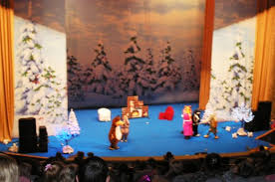  market  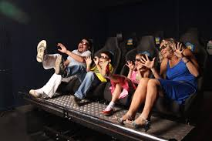  bowling  theatre 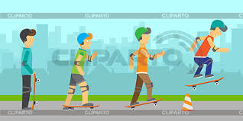  swimming pool 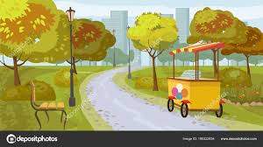  park  Activity 2. Reading. (FA)  Learning objectives 3.3.5.1- understand the main points of short simple texts on a limited range of  familiar general and some curricular topics by using contextual clues  Assessment criteria identify the main points of the text using contextual clues  Level of thinking Knowledge Application  Task. Read the text and mark if it is True or False. Active method “Scanning”  Places for fun  I am fond of good books and good music, and when I have some time to spare, I like to go to the theatre or a concert. There are 2 big concert halls in London. The Old Royal Albert Hall and the New Royal Festival Hall. There are about 200 professional theatres in Britain.  I am not particularly fond of the cinema. Although, if the movie is interesting, I like to go to the movies.  I prefer features films or popular science films. I usually go to the cinema for the morning or day shows.  If I want to relax in the evening I go for a walk in the park. It is a good idea for a rest.  On weekends, my friends and I go bowling and skateboarding.  Sometimes my mother and I go to the market. It's really exciting. The market sells a variety of things that I like.  Helen.  Mark if the statements are True or False.  - Helen is fond of good books and music.  - She does not go to the theatre or a concert.  - She is fond of the cinema.  - Helen usually goes to the cinema for the evening shows.  - She goes bowling and skateboarding on Friday.  - She thinks the market is an exciting place for shopping.  Descriptor A learner  -reads the text  -identifies the main points of the text using contextual clues  -marks if the statements are True or False  Relax time. Game “What am I doing?”  Let’s Play  Explain the game. Ask a pupil to come to the front of  the classroom and mime an action. The rest of the class  tries to guess the action.  e.g.  Pupil 1: (mimes playing bowling ) Pupil 2: Are you playing bowling? Pupil1: Yes, I am. Etc.  Activity 3. Speaking.  Task. Look at the pictures and answer the given questions.  Active method “Think-Pair-Share”. Each group has got the poster with question and pictures. The group should answer the questions using pictures then compose a short story. Allow time for learners they are thinking in response to the question. At the end of the activity students answer all questions.  Posters.  Poster 1  - What fun place does Carol like to go to?  - Who does Carol go to the fun place with?  - What cartoon does she watch?  Poster 2  1. What fun place does Tom like to go to?  2. Who does Tom go to the fun place with?  3. What animal does Tom feed in the zoo?  Poster 3  - What fun place does Omar like to go to?  - Who does Omar go to the fun place with?  - When does Omar go to the fun place?  Descriptor A learner  -looks at the pictures and answers the questions  -makes a short story according to their answers  -pronounces the words intelligibly  Differentiation by outcome.  Peer assessment |  | Flashcards  https://englishtopic.ru/entertainment/  Handout 1.  Posters
End  5 min | Feedback.  Strategy “Ladder of success”  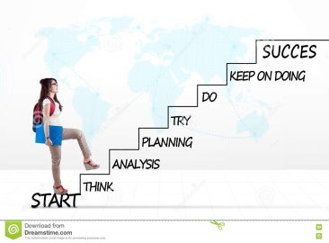  Learners label stickers with their achievements.
Additional information
Differentiation – how do you plan to  give more support? How do you plan  to challenge the more able learners?  More support will be given to weaker learners by giving them a modified worksheets in some tasks with greater support |  | Assessment – how are you  planning to check learners’  learning?  - Through formative assessment  - Through observation of the stage of speaking |  | Health and safety check  ICT links  - Health promoting techniques  - Breaks and physical activities used.
Differentiation by outcome. |  | Peer assessment  Teacher provided assessment |  | Points from Safety rules used at this lesson
Reflection  Were the lesson objectives/learning objectives realistic?  What did the learners learn today?  What was the learning atmosphere like?  Did my planned differentiation work well? |  | Use the space below to reflect on your lesson. Answer the most relevant questions from the box on the left about your lesson.
Summary evaluation
What two things went really well (consider both teaching and learning)?
1:
2:
What two things would have improved the lesson (consider both teaching and learning)?
1:
2:
What have I learned from this lesson about the class or individuals that will inform my next lesson?

