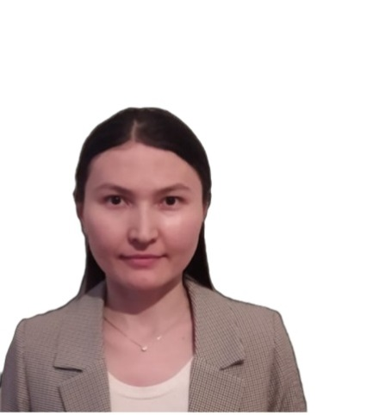

Альжанова Айдана Рамазанқызы
Павлодар қаласы
Б.Момышұлы атындағы
жалпы орта білім беру мектебінің
ағылшын тілі пәні мұғалімі

Conditionals

Teacher’s name | Alzhanova Aidana Ramazanovna
Grade / Date | 8
The theme of the  lesson: | Unit IV. Conditionals
The reference: | Excel for Kazakhstan Student’s book Grade 8  Virginia Evans, Jenny Dooley, Bob Obee
Goals: | All learners will be able to: recognize and understand the form and use of conditionals.  Most learners will be able to: apply the conditionals to talk about imaginary situations.  Some learners will be able to:produce extended sentences using the conditionals.
Grammar: | Present simple, Past simple, Conditionals
Cross curricular links | Kazakh language
Use of ICT | Computer for showing a presentation, getting additional information, playing the audio files
Health and Safety | Breaks and physical activities

1.The organization  Moment: | Greetings!  Revising the Present simple and Past simple forms | 3 m.
2. Main part.  Reading the theory.  Teacher shows the presentation and explain the main difference between 0,1,2 conditionals  Gives the examples | 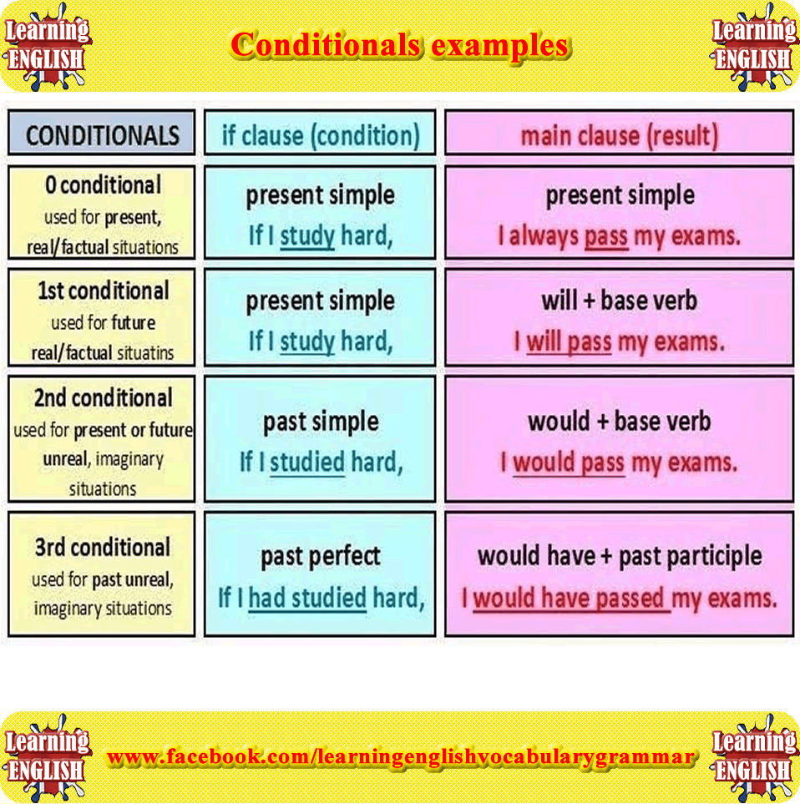 | 10-12 m.
3. Use of ICT  Watching the video and discuss | https://youtu.be/PiBLQfNb8RQ | 5-7 m.
4.Games  1.Teacher can use interactive game  2. “If game”  Students are divided into 3 groups. Teacher shows flashcards and students should quickly make sentences | 1. https://www.gamestolearnenglish.com/conditional-sentences/  2. if it rains, ……  If I had …., I would
5.Physical training | Let’s have a break and relax listening to the melody | 2-3 m
6. Exercises: | 1.Page 45 exercise 7  - 2. Match the two halves of these sentences.  If I  come home late,  go to the wood,  find my book,  lose my money,  see my friend,  receive the letter,  fall ill,  be very glad.  go to the doctor.  be very glad.  go to bed at once.  bathe every day.  be very glad.  ask his advice. | 10 m.
7.Reflection  Conclusion | Ok, let’s summarize our lesson. What have you learnt today?  Today you worked very well. I’m satisfied with your activity.  Our lesson is over! Good bye! | 5 m
8.Home task | Page 45 exercise 10 | 1 min

